Street Design and Safety Committee Meeting

April 30th, 2026
12:00pm-1:30pm
Virtual (Microsoft Teams)

Attendees:

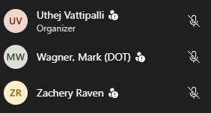
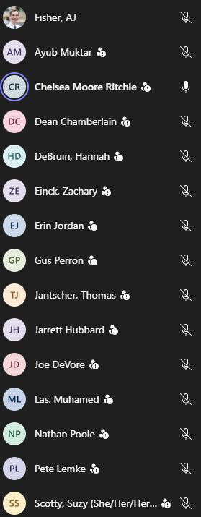

Agenda:
- Introductions
- Committee Updates
- MnDOT School Zone Speed Limit Guide Presentation
- Q&A
- Next Meeting: June 25th, 2026?

